Intellective Solutions
45 Shiv Shakti Nagar,
Kanadia road,
Indore-16
INDIA.
www.hamaramp.com
Solutions At Work
Sub: KickOff checklist
Dear Sir or Madam:
Thanks for your interest in our product FontCosine. Given below is the kickoff checklist you requested:
- Product Name: FontCosine
- Product Version: 1.0
- Release date: 1/7/2001
- Product currently on tucows: No
- Platforms Supported: Windows 2000/ME/NT/98
- System Requirements: 233 MHz Processor, 16MB RAM, 256- color compatible VGA Card, and 5 MB Free Disk Space.
- Intellective Solutions is small company run by Vaibhav Jain and Vikas Chauhan aiming at providing innovative solutions to the computer industry.
- Intellective Solutions
- Phone number: 91-731-592093
- Fax number:91-731-592093
- E-mail Address:intellective@sify.com
- Company Home page URL : http://www.hamaramp.com
- Company logo:
- Screen capture:
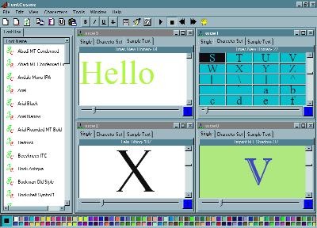
Application Location: http://www.hamaramp.com/fcsetup.exe
Product Description:
FontCosine is a tool for previewing fonts on Windows systems. It is aimed at users who deal in fonts regularly. As system can have a large number of installed fonts & going through all of them and to choose which one fits best to a particular scene can be a very cumbersome processes, especially when the number of fonts installed is very large. Present Font previewing utilities do not provide much features to make this job easier. Aiming this need in mind, we wrote FontCosine; a complete Font Previewing Utility. Fontcosine is made with the users in mind and is aimed at making working with font a lot easier and faster.
License Type: Shareware
Evaluation Period: 30 days
Cost: US$15.00
Platforms Supported: windows 98/ME/NT/2000
Suggested Category: designing-Font-Viewers
Would you be willing to provide TUCOWS with a registered version of your
Software/service to evaluate/review? Yes

Sincerely,
Vaibhav Jain

Director,
Intellective Solutions

